Section 0: Use GIT as local VCS.

1. Create a directory ‘project_dir’ & cd to ‘project_dir’.

Solution: 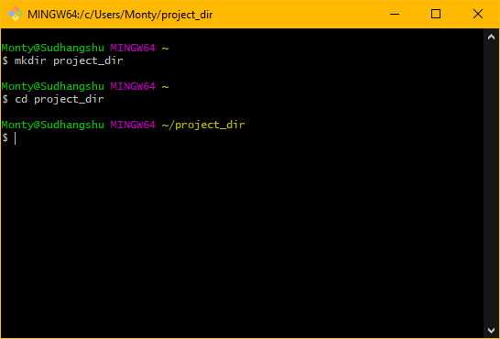

1. Initialize git version database.

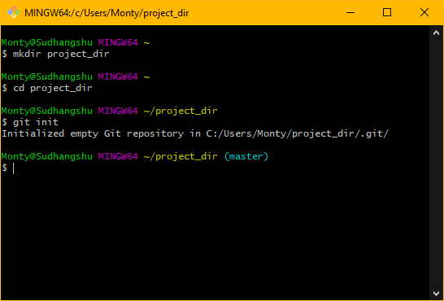

1. **Create a new file index.html**

touch index.html

1. **Check the git status. You should find index.html as untracked file.**

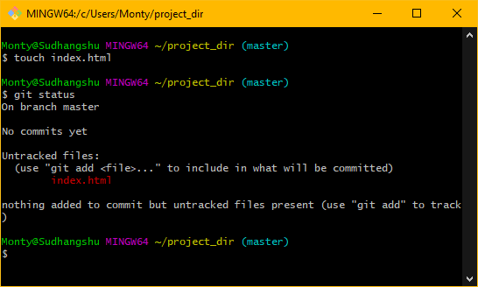

1. **Stage the index.html file**

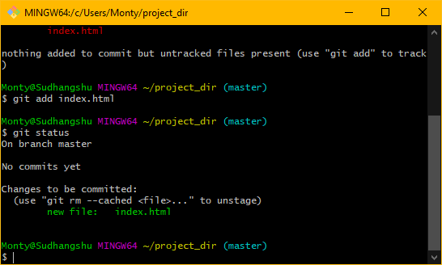

1. **Commit index.html**

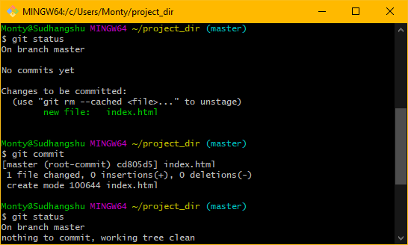

1. **Make a few changes in the index.html file and create a new file info.txt.**

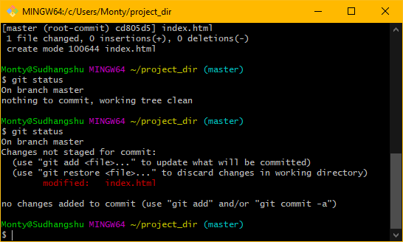

touch info.txt

1. **Check git status. You should find index.html & info.txt as untracked files**

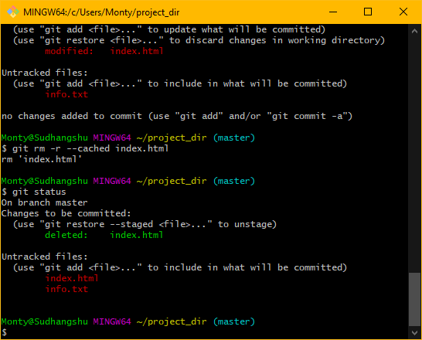

1. **Configure git to ignore all text files.**

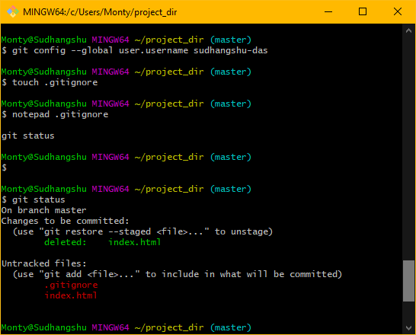

1. **Again check the git status. You should find only index.html as untracked file.**

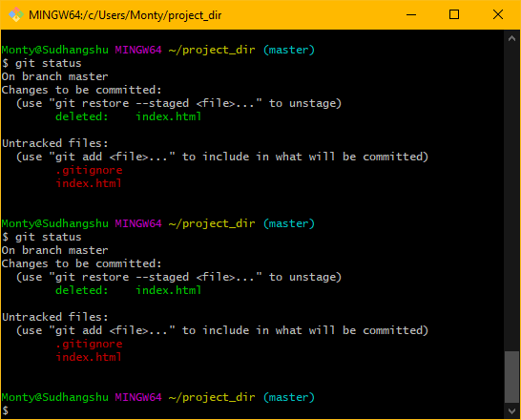

1. **Stage and commit index.html**

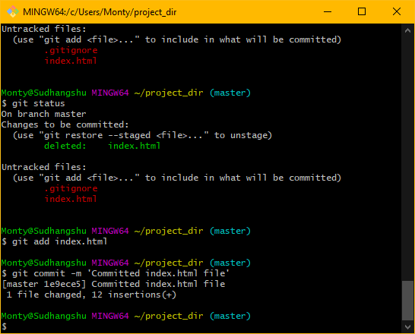

1. **Log all your comments so far.**

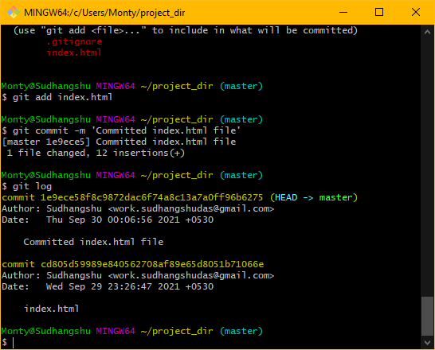

1. **Make some changes in the index.html file**

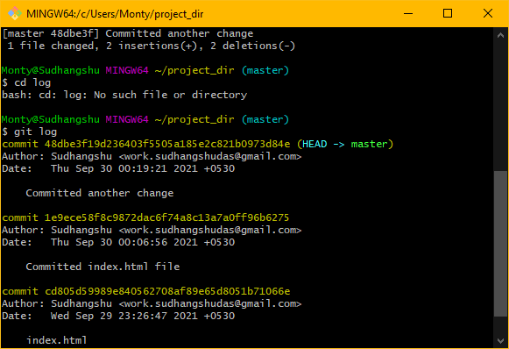

1. **Revert the change in the previous step using git command**

git revert HEAD

1. **Again change index.html**

git add index.html

1. **Stage index.html**

git add index.html

1. **Revert back the last change**

First commit:

git commit –m “Another change has been made”

git revert HEAD

1. **Rename ‘add’ command to ‘my-add’.**

git config --global alias.my-add add

1. **Using my-add command, Stage the index.html again and commit the changes**

git my-add index.html

git commit -m “Change committed using the my-add command”

1. **Revert the last commit**

After committing the changes,

git revert HEAD

SECTION – 1 (HTML Assignments)

1. **Create and empty directory ‘Assignments’ and cd to ‘Assignments’**

mkdir Assignments

cd Assignments

1. **Create a README.txt inside ‘Assignments’ & write few lines about the contents of the ‘Assignments’ folder.**
2. **Commit README.txt file.**

git add README.txt

git commit –m “Committed with the first change”

1. **Now create new branch ‘html-assignments’**

git branch html-assignments.

1. **Switch to ‘html-assignments’ branch.**

git checkout html-assignments

1. **Copy all HTML assignments inside the ‘Assignments’ folder.**
2. **Commit HTML assignments into ‘html-assignments’ branch.**

git add index.html

git commit –m “First commit in new branch”

1. **Make minor changes into few files belonging to ‘html-assignments’ branch.**

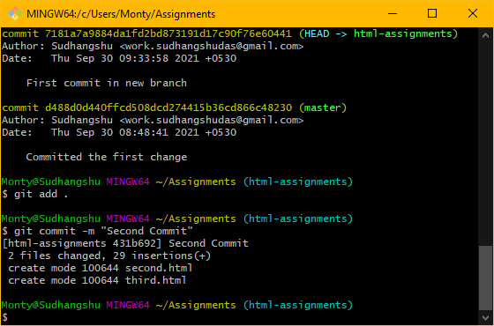

1. **Commit those changed files.**

git commit –m “Second commit in this branch”

1. **Switch to master branch.**

git checkout master

1. **Make minor changes into README.txt file & commit those changes into master.**

git add README.txt

git commit –m “Some minor changes made in the README.txt file”

1. **Again switch to ‘html-assignments branch’.**

git checkout html-assignments

1. **Make minor changes into few files belonging to ‘html-assignments’ branch.**

Changes made. Then,

git add .

1. **Commit those changes.**

git add commit –m “Minor changes made in few files of ‘html-assignments branch”

1. **Switch to master.**

git checkout master

**SECTION – 2 (CSS Assignments)**

1. **Create a new branch ‘css-assignments’.**

git branch css-assignments

1. **Switch to ‘css-assignments’ branch.**

Git checkout css-assignments.

1. **Copy all CSS assignments inside ‘Assignments’ folder.**

Made 3 CSS files:

touch style1.css

touch style2.css

touch style3.css

1. **Commit all CSS assignments inside Assignments folder.**
2. **Make minor changes into README.txt file on line1 belonging to ‘css-assignments’ branch.**

Changes made.

Then added those files in the staging area using:

git add .

1. **Commit those changes.**

git commit –m “Committed changes to css files in the ‘css-assignments’ branch.

1. **Switch to master branch**

git checkout master

1. **Make minor changes into README.txt file on line 3 & commit those changes into master.**

Made changes.

git add .

git commit –m “Changes made in the README file”

1. **Again switch to ‘css-assignments’ branch.**

git checkout css-assignments

1. **Make minor changes into few files belonging to the ‘css-assignments’ branch.**

Changes made.

git add .

1. **Commit those changes**

git commit –m “Changes made in the 3 CSS files”

1. **Switch to master.**

git checkout master.

1. **Merge ‘css-assignments’ into master branch. Confirm all CSS assignments are shown in master.**

git merge css-assignments.

Comment in the vim: All CSS copies are there in the master branch.

1. **Finally delete the ‘css-assignments’ branch.**

git branch –d css-assignments

**SECTION – 3 (JavaScript assignments). Steps to follow:**

1. **Create a new branch ‘js-assignments’.**

git branch js-assignments.

1. **Switch to ‘js-assignments’.**

git checkout js-assignments

1. **Copy all JavaScript assignments inside ‘Assignments’ folder.**

Making JS files in the Assignments folder:

touch script1.js

touch script2.js

touch script3.js

1. **Commit JavaScript assignments into ‘js-assignments branch’.**

git add .

git commit –m “Committed JavaScript assignments to ‘js-assignments’ branch

1. **Make minor changes into README.txt file on line 1 belonging to ‘js-assignments’ branch.**

Changes made in the README.txt file of the ‘js-assignments’ branch.

1. **Commit those changed files.**

git add .

git commit –m “Changes made in the JavaScript file are committed”

1. **Switch to master branch.**

git checkout master

1. **Make minor changes into README.txt file on line 1 & commit those changes into master.**

Minor changes has been made in the README.txt file in the master branch.

Committing the changes:

git add .

git commit –m “README.txt” file committed with minor changes.

1. **Again switch to ‘js-assignments’ branch.**

git checkout js-assignments

1. **Make minor changes into few files belonging to ‘js-assignments’ branch.**

Changes made in the JS files.

1. **Commit those changes.**

git add .

git commit –m “Changes are made on the JS file”

1. **Switch to master**

git checkout master

1. **Merge ‘js-assignments’ branch into master. Confirm all JavaScript assignments are shown in master.**

git merge js-assignments

**SECTION-4 (Pushing assignments into repository)**

git config –global user.email [work.sudhangshudas@gmail.com](mailto:work.sudhangshudas@gmail.com)

git config –global user.username Sudhangshu-das

git remote add origin <repo link>

git push origin master